Long Island Village Clerks and Treasurers Association, Inc.
LIVCTA.COM
Marianne C. Lobaccaro  President  North Hills | 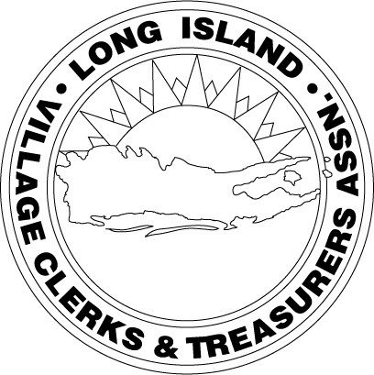 | Joanna Palumbo  Nassau Director  Sands Point
David Fraser  1st Vice President  City of Long Beach |  | Ronnie Shatzkamer  Nassau Director  Flower Hill
Liz Gaynor  2nd Vice President  Sands Point |  | Patricia C. Carley  Suffolk Director  Babylon
Arta Wintjen  Treasurer  Babylon |  | Bob Juliano  Suffolk Director  Port Jefferson
Barbara Kelly  Secretary  Farmingdale |  | Joseph R. Scalero  Executive Committee  Mineola
Robert P. Smith  Association Counsel  Hawkins Delafield & Wood LLP |  | John Mirando  Executive Committee  City of Long Beach

FEBRUARY MEETING NOTICE

Employee Policies and Handbook

WHEN: Thursday, February 8th, 12:00 PM
12:00-12:30 PM – Meet & Greet
12:30 PM Meeting begins
WHERE: Milleridge Inn
585 N Broadway
Jericho, NY 11753
EVENT: Bee Ready Fishbein – Employee Policies and Handbook

COST: Members $30, Non-members $40

RSVP: Please RSVP EMAIL: MeetingRSVP@livcta.com

The Executive Board would appreciate you reaching out to other Villages and Vendors you associate with and encourage their attendance and participation with our Association.

