Long Island Village Clerks and Treasurers Association, Inc.
LIVCTA.COM
Marianne C. Lobaccaro  President  North Hills | 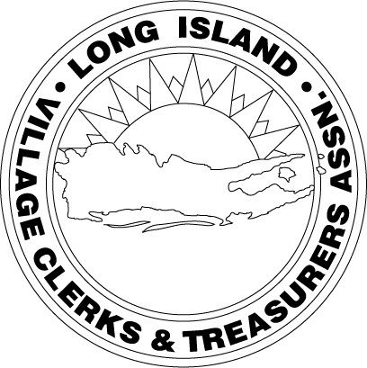 | Joanna Palumbo  Nassau Director  Sands Point
David Fraser  1st Vice President  City of Long Beach |  | Ronnie Shatzkamer  Nassau Director  Flower Hill
Liz Gaynor  2nd Vice President  Sands Point |  | Patricia C. Carley  Suffolk Director  Babylon
Arta Wintjen  Treasurer  Babylon |  | Bob Juliano  Suffolk Director  Port Jefferson
Barbara Kelly  Secretary  Farmingdale |  | Joseph R. Scalero  Executive Committee  Mineola
Robert P. Smith  Association Counsel  Hawkins Delafield & Wood LLP |  | John Mirando  Executive Committee  City of Long Beach

MAY MEETING NOTICE

Year End Accounting

WHEN: Thursday, May 10, 2018 12:00 PM
WHERE: Lilly Flanagan’s
345 Deer Park Ave.
Babylon, NY 11702
SPEAKER: Jim Olivo BST & Co. & Marianne Van Duyne, R.S. Abrams & Co.
COST: Members $30, Non-members $40

RSVP: Please RSVP EMAIL: MeetingRSVP@livcta.com

June meeting - WEDNESDAY, June 13th, Hendrick’s Tavern Roslyn

