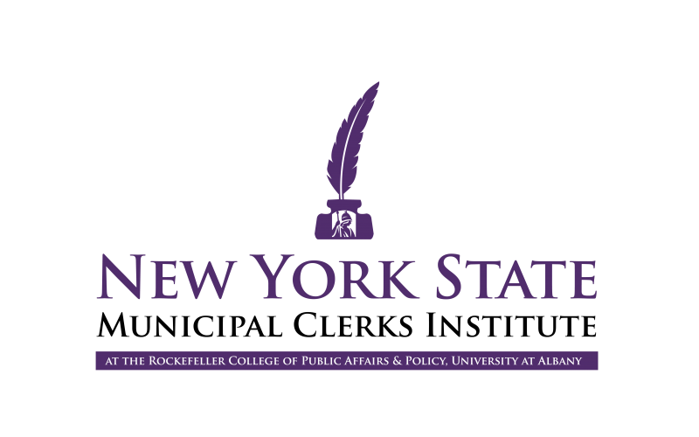

Rockefeller College of Public Affairs & Policy is hosting online courses for the Certified Municipal Clerks (CMC) and the Master Municipal Clerks (MMC) training programs. Clerks seeking professional certification through the International Institute of Municipal Clerks (IIMC) as well as other municipal officials seeking professional development are welcome to participate. Clerks will be able to earn four points in the spring semester. Courses will be offered live via Zoom 4-6pm.

Spring 2021 Online Courses

April 28, 2021

Knowing Your Networks: Building Relationships to Further Personal and Organizational Goals
Instructor: R. Karl Rethemeyer, Dean, Rockefeller College of Public Affairs and Policy
The purpose of this course is to have participants think about the concept of networks and networking in a rigorous fashion using ideas drawn from the study of groups and organizations. Once a common set of ideas and a symbolic language for understanding social networks is introduced, participants will then go through an exercise to draw a visualization of their professional social network. Using these visualizations, participants will complete a set of exercises to think about which professional resources are plentiful and which are scarce in their network and why that might be. Finally, participants will learn how networks can be extended and “improved” through professional networking.
May 12, 2021

Leadership Principles and Practice
Instructor: Eugene Monaco, Director, New York State Municipal Clerks Institute
Today’s municipal clerks are implicit leaders who can influence and implement improvements and innovations in day-to-day governmental operations. Understanding the principles of leadership and being aware of alternative styles of leadership are important aspects of today’s job and they will be highlighted throughout this course. Through a case study exercise, participants will apply the principles of leadership to underscore their understanding of leadership principles and practice.

Registration
Spring 2021 Online Courses: $50
Scholarships may be available! Check with your State and Regional Associations for more information.
Click here to register and pay online (online registration and payment via credit card is preferred).
For those who must pay by check, please click here to download the form.
Registration for each session will close one week prior to class meeting.
Registrants who are no longer able to participate must cancel their registration one week prior to the class meeting to receive a refund.

