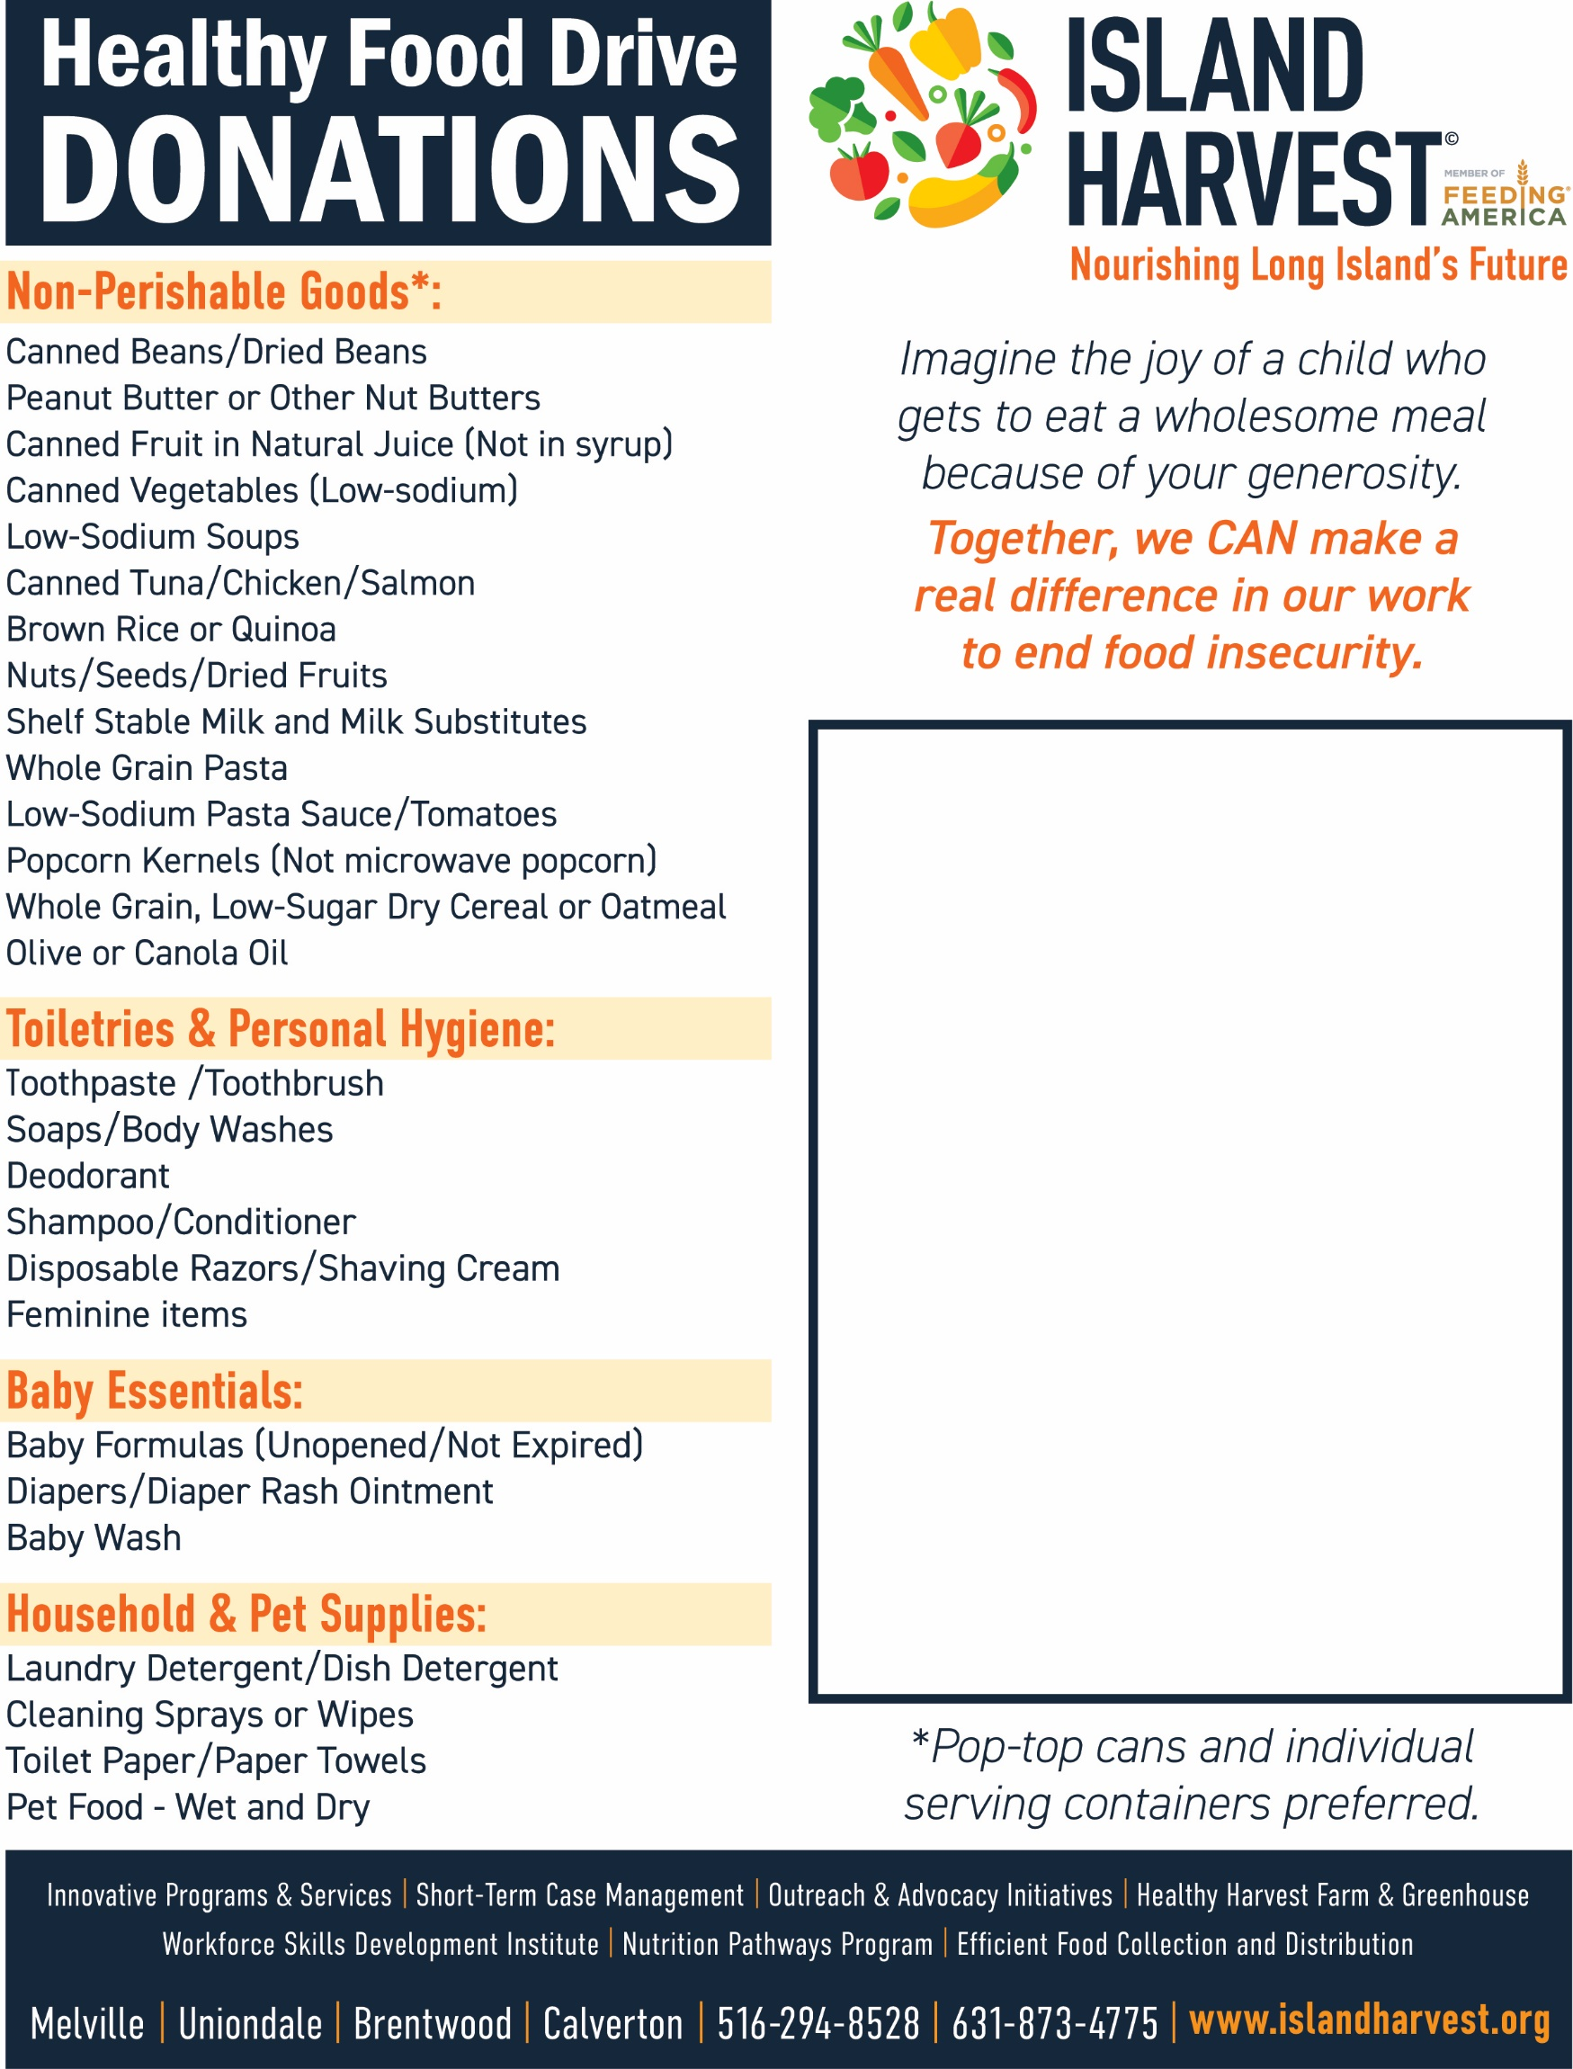

2026 Long Island Village
Clerks & Treasurers Association

Forgot Your Food? You can still help!
Please Scan QR Code to Contribute
$1 Helps Support 2 Meals

